Exploratory Data Analytics Insights: -

**Summary Statistics: -**

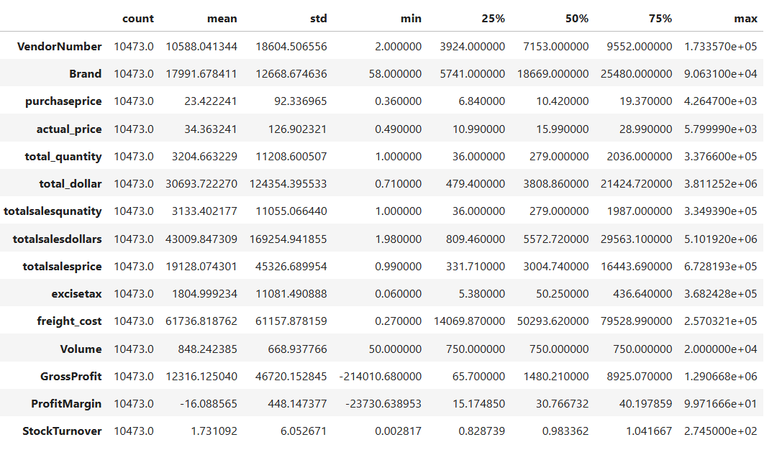

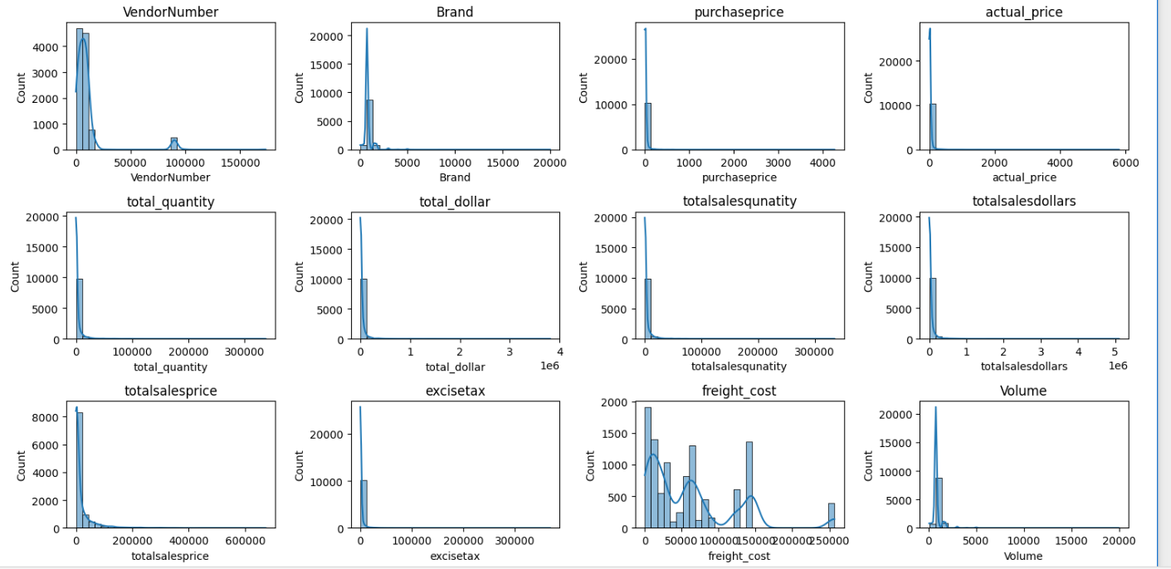

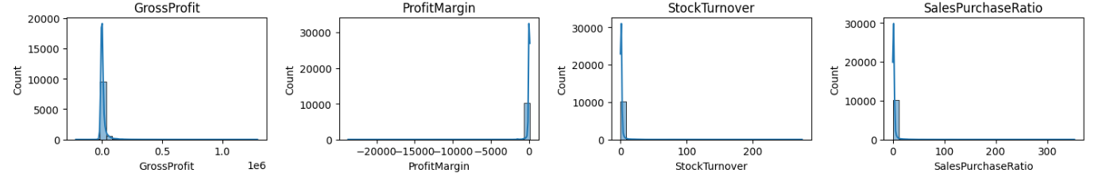

**Insights from Summary Statistics: -**

1. Negative Values: -
   * Gross Profit: - Minimum value of gross profit is -214010.68000 which indicates that some products may be sold at loss due to higher cost or sold at discount which is less than purchase price.
   * Profit Margin: - Minimum value -23730.638953 is negative means revenue is lower than the purchase cost of the product.
2. Outliers indicated due to higher standard deviation: -
   * Purchase & Actual Price: - Maximum value of the purchase price than the mean indicates that, some products are the premium products with higher cost.
   * Stock Turnover: - 0.002817 to 2.745000e+02 indicates that some products sold out more while some remains in stock. Value more than 1 indicates that sold quantity is more than purchased quantity due to the sales are fulfilled from older stock.
   * Freight Cost: - Huge variation of the cost from 0.270000 to 2.570321e+05 shows the bulk shipment or logistics inefficiencies.

Data Filtering: -

To improve the accuracy of the data insights, we have removed some inconsistency from the data. Below are the 3 filters that we have applied.

1. Profit Margin > 0 (To ensure to focus on profitable transactions.)
2. Gross Profit > 0 (To ensure to focus on profitable transactions.)
3. Total sales Quantity > 0 (To eliminate the inventory that was never sold.)

**Correlation Insights: -**

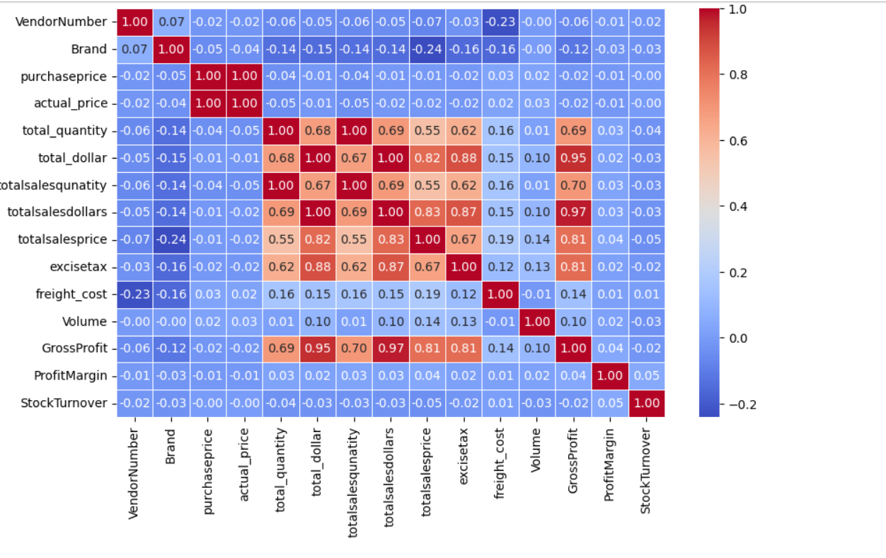

* **Purchase price VS sales dollar & gross profit:** - Purchase price has negative weak correlation with total sales dollar (-0.01) & gross profit (-0.01) shows that price variation does not affect the sales as well as profit
* **Sales quantity VS total purchase quantity: -** Strong correlation between the total sales quantity & total purchase quantity shows the efficient inventory turnover.
* **Stock turnover VS profit margin: -** Stock turnover has negative weak correlation (-0.02) with profit margin which shows that higher stock turnover does not implies more profit.

**Research Questions & Key Findings: -**

1. **Brands for promotional or pricing adjustments.**

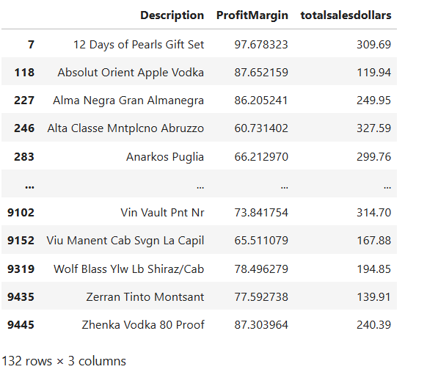

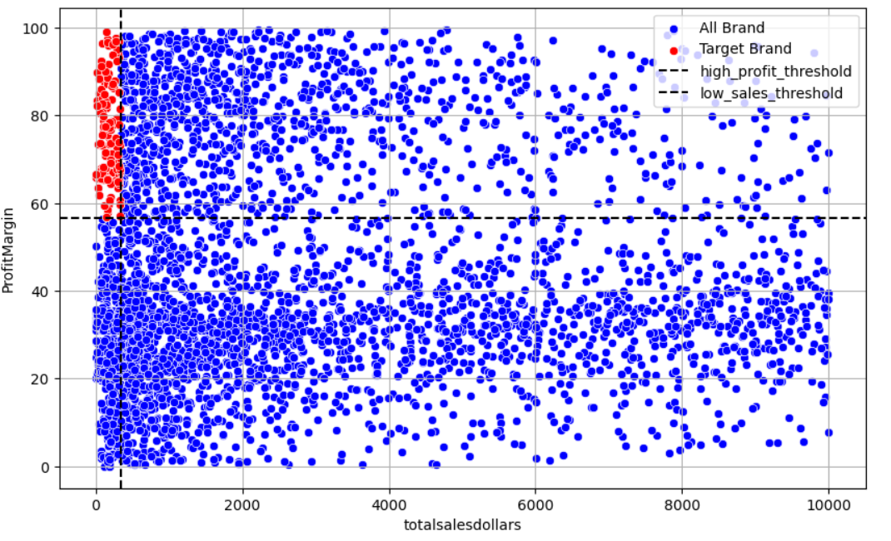

132 brands exhibit the lower sales performance, but higher profit margin. They can get the benefit by pricing adjustments, marketing & promotions.

1. **Top vendor by sales & there purchase contributions: -**

Top 10 vendors contributions to sales are 65.54 % & remaining other has 34.5% contribution. This shows the over-reliance on top 10 vendors only. This can lead to risk like supply chain disruptions. Needs the diversification.

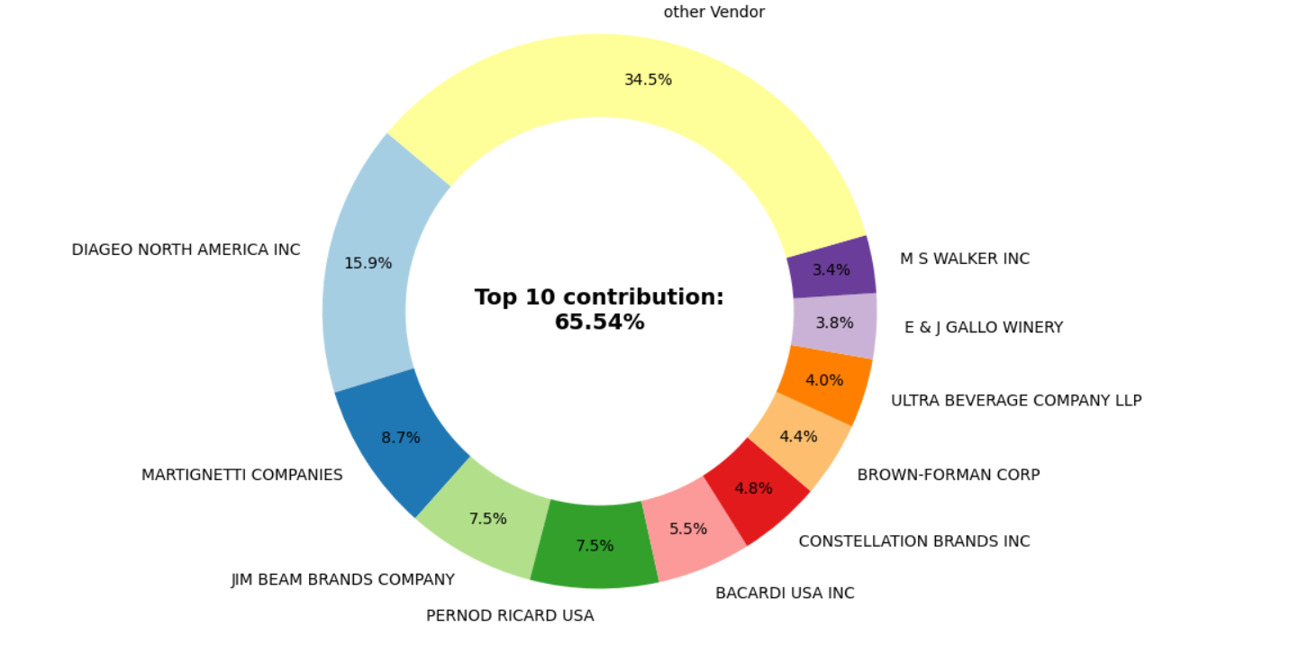

1. **Impact of Bulk purchasing on Cost Savings: -**

Vendors buying in bulk receives the 72% lower unit price than the smaller orders. Hence, we can say that, bulk pricing strategies increases the sales.

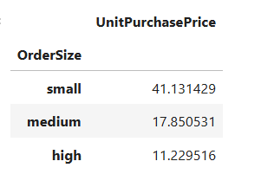

1. **Identifying the vendors with Low Inventory Turnover: -**

Total Unsold Inventory Capital:- 9172221.319999997

Slow-moving inventory increases storage cost, reduce cash flow capabilities.

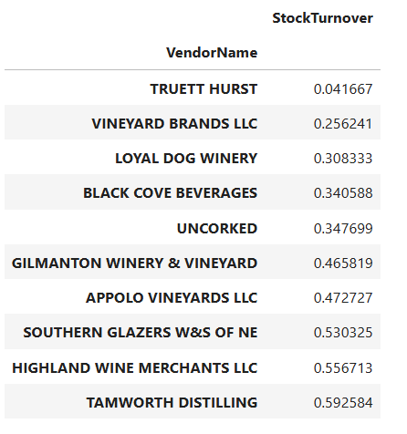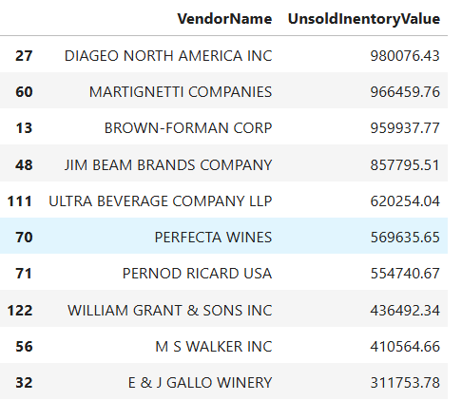

1. **Profit Margin Comparison: High vs Low Performing Vendors**

Low Vendors Profit Margin (95% CI): - (40.53 % to 38.21%), Mean:39.37%

Top Vendors Profit Margin (95% CI): - (30.32% to 29.23%), Mean:29.78%

Low-Performing Vendors gives higher profit margin, means they struggles with sales volume, indicating pricing efficiencies or marker reach issue.

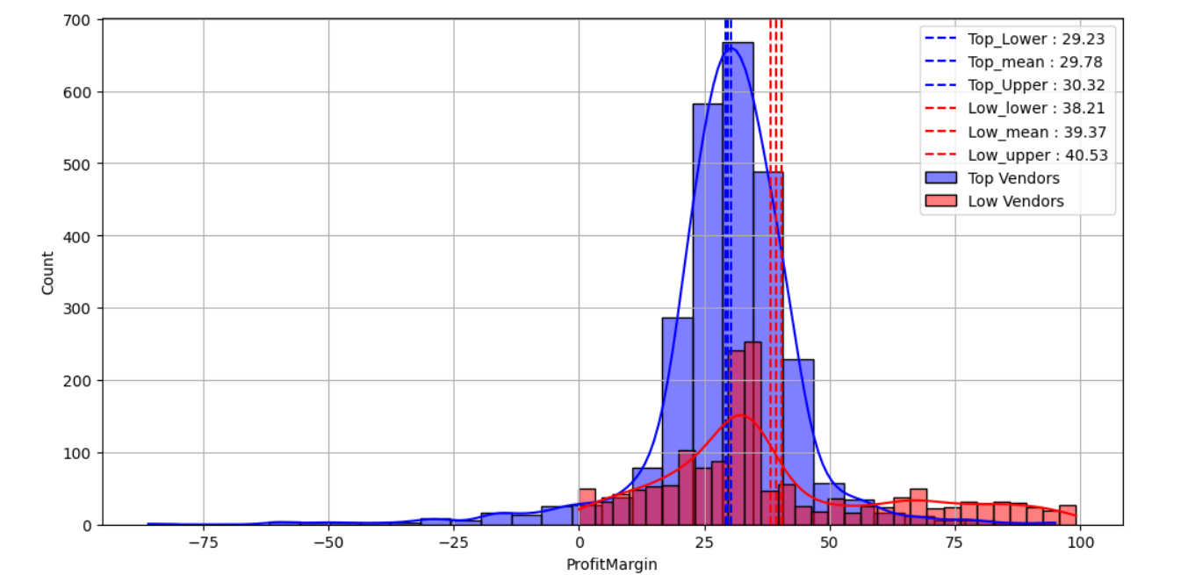

1. **Statistical Validation for the Profit Margin: -**

**Hypothesis Testing**

Null Hypothesis H₀: - There is no significant difference between the mean profit margin of top-performing & low-performing vendor.

Alternative Hypothesis H1: - The mean profit margins of top-performing vendor & low-performing vendor is different.

**Result: -** Reject H₀: There is significant difference between profit-margins of top-performing & low-performing vendor.

**Final Recommendations: -**

* Re-evaluate the pricing for low-sales with higher profit margin to boost sales volume.
* Diversify the vendor partnerships to mitigate the risk of supply chain disruptions.
* Leverage the bulk pricing advantages to maintain competitive pricing.
* Optimize the slow-moving inventory by adjusting purchase quantity & launch clearance sales.
* Enhance marketing & distribution strategies for low performing vendors without comprising the profit margin.